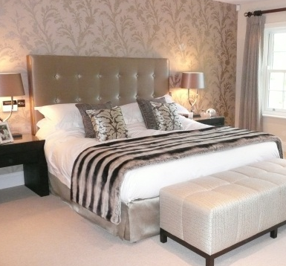

ia DESIGN
ia design interiors llp
6 Coombe Bank
Kingston upon Thames
Surrey KT2 7DN
Tel & Fax: 020 8942 2266
www.iadesign.co.uk
info@iadesign.co.uk

Mike Farmer
Mr Carpet
308 Worple Road
London
SW20 8QU

22nd May 2012

INVOICE 2732

For Commission in respect of the following client referrals

R16106 Carolides £ 70.00
R16217 Coleman £ 75.00
R16233 Wooldridge/R £250.00

Plus Vat @ 20% £ 79.00

Invoice Total £474.00

Total ex Vat: £395.00
Vat @ 20% £ 79.00
Total inc Vat: £474.00

Please make cheques payable to ‘ia design interiors llp’
Or by bank transfer:
HSBC Sort code: 40 34 24
Account Number: 51504185

W18 1EG

Registered in England and Wales
Registered Number: OC333559
Vat Number: 752 1460 52

