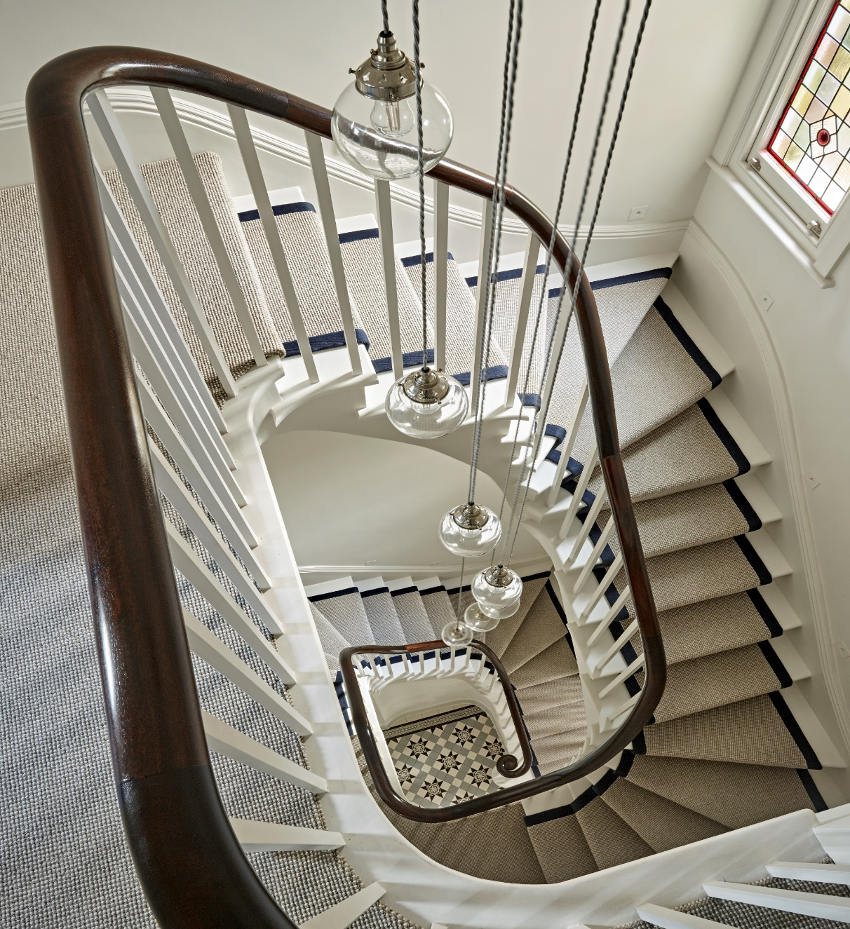
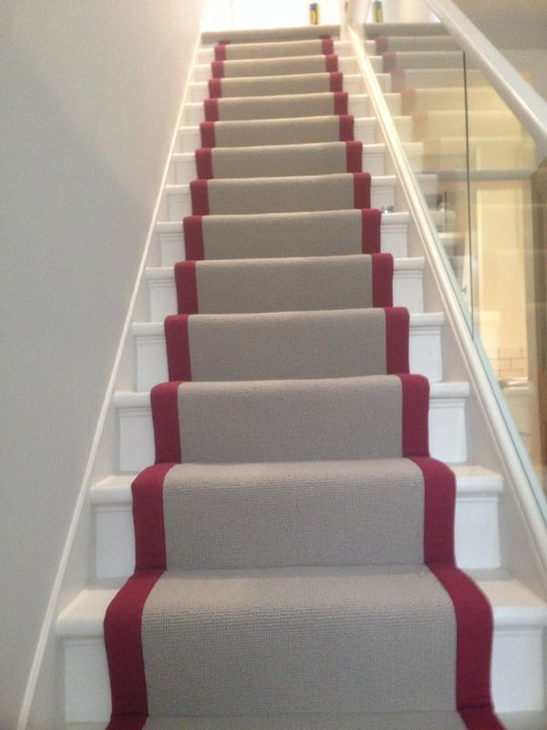



Further to our site survey, please find attached our quotation to supply and lay your selected flooring

This quotation is covered by our price match guarantee so please contact us if you obtain a lower price for these goods and services and we will match or beat our competitors quote subject to certain terms & conditions.

      Mrs Janet Falush  S35946 |  |  |  | 
293-299 Upper Richmond Road West
East Sheen, London
SW14 8QS
020-8876-9126
sheenbranch@mrcarpetlondon.co.uk

Mrs Janet Falush
29 Glebe Road,
London
SW13 0DZ

5th December 2025

Quotation Reference: S35946

Stairs
To supply & fit Brooklyn BRO/W05 @ £20.00 m² (Reduced from £25.00 m²)
Luxury 10mm PU Foam underlay to be laid beneath,
Re-use existing gripperods throughout,
Stairs to be fitted full width (not as runners),
Uplift & dispose of the existing carpet & underlay included.

Normal Retail Price £ 841.00
Less Current Promotional Discount - £ 69.00
Discount Price (Valid until 20/12/2025) £ 772.00

Xmas 2025 offer
Orders placed between 01/11/2025 and 29/11/2025 and are fitted in January 2026 are subject to 10% discount providing the balance is paid 48 hours prior to fitting.
A 50% deposit of the total is payable at order, with the 10% discount reduced from your balance payment ahead of the fitting.

Less Xmas 2025 offer - £ 77.00
Discount Price (Valid until 20/12/2025 only) £ 695.00

Payment terms
50% deposit required to place order & balance to be paid at least 2 working week days (Monday-Friday) before 1st day of installation (or after 30 days from the date of order placement, whichever comes first – see terms & conditions)

All prices include VAT @ 20%
IMPORTANT INFORMATION – please read!
We appreciate no one enjoys reading through paragraphs of technical jargon, but the following few paragraphs are worth a read through to either answer any questions you might have, or help you know which questions you’d think are worth raising to us

Deposit & Balance – A 50% deposit payment is required to schedule a fitting date & for goods to be ordered in. The balance payment is due 2 working week days (Monday-Friday) before the 1st day of installation. If there is a delay in obtaining the balance & fitting cannot go ahead as scheduled, a loss of earnings charge may be due for the installation team. More information in Terms and Conditions on final page.
Refunds – Due to bespoke materials being ordered, once an order has been placed, it is impossible to obtain a full refund. Please ensure before order placement that all information on the quotation is correct and you are satisfied to proceed.
Door trimming – It is often necessary to have doors trimmed prior to new carpets being installed. Our fitters do not trim doors; however, we are able to provide all required flooring height specification of your selected materials to ensure proper clearance.
Furniture Moving – It is the responsibility of the customer to clear all personal effects, breakables, movable items of furniture, computer and home entertainment equipment from the areas to be carpeted prior to our fitter’s arrival.
Pile Direction – The quotation is quantified as economically as possible. If the chosen carpet has a distinct pile direction, please get in touch to discuss if you have any specific requirements the pile direction is ran.
Runners – If you are having your stairs freshly painted in preparation for the runner, please bear in mind (with the quite forceful method required to install a runner) there is the potential for hairline cracks in the paint, or in the worst case scenario (if your stair case structure is weak) cracks and splits in the stair case themselves. This is not something Mr Carpet can be held responsible for and you will need to arrange any remedial work required to finish the job if need be.
Skirting Boards – Through the process of fitting a new carpet, a necessary level of force is required to ensure the carpet itself is securely fixed between the gripperod & skirting board. Please note that if a skirting board is not properly attached to the wall this may result in it pushing in at the base & coming away from the wall at the top. This is not a consequence of poor installation from our fitter therefore this is not something Mr Carpet can be held responsible for and you will need to arrange any remedial work required to finish the job if need be.
Floorboards – Any unevenness in floorboards will show through to the pile of a fitted carpet after installation as carpet & underlay are soft materials, and will shape out to whatever they are laid on top of. Please ensure that floorboards are levelled prior to our visit, in some cases it may be necessary to have hardboard or plywood laid over the floorboards to negate this issue. This is also a service we can provide at an additional cost.
Painted/Wallpapered Walls – Mr Carpet cannot be held responsible for any remedial works for scuffs/damage from transporting materials into and around the home. Quite often, large pieces of carpet are required to be moved up narrow hallways and staircases which make it impossible to guarantee the carpet will not come into contact with a wall at least once, same can be said regarding unrolling carpets out inside a room, as carpets need to be bigger than the space they will be installed to so contact is also highly possibl
Terms and Conditions of Trading

1 Definitions
1.1 “The Company” means Mr Carpet (London) Limited (and/or licensed Franchises operating under the name of Mr Carpet).
1.2 “The Customer” means the customer as stated overleaf.
1.3 “The Materials” means the materials described overleaf, whether in detail or by reference to a previous specification.
1.4 “The Site” means the customer’s premises (or other delivery address as shown overleaf).
1.5 “The Contract” means the contract for the sale of goods and services by the Company to the Customer.
1.6 “Head Office” means the offices of the central administration of the Company, not necessarily the registered offices.
1.7 “Working days” means MONDAY to FRIDAY inclusive.

2 General
2.1 Unless otherwise agreed in writing by Head Office these terms and conditions shall apply to all orders placed with the Company by the Customer.
2.2 These conditions shall be incorporated in the Contract to the exclusion of any terms or conditions stipulated or referred to by the Customer.
2.3 No variation or amendments of this Contract shall be binding on the Company unless confirmed in writing by Head Office.

3 Acceptance
3.1 A Contract price given by the Company is open for acceptance by the Customer for 28 days. Queries regarding quantities of materials, methods of fitting, position of joins etc. must be resolved before acceptance thereof.
3.2 All prices quoted by the Company are inclusive of Value Added Tax (charged at the rate applicable at the date of invoice), unless otherwise stated.
3.3 Where measurements are provided by the Customer and are not subject to prior confirmation and checking on Site by the Company the Customer is liable for any errors resulting from incorrect measurements. If requested by the Customer to carry out any additional or remedial work necessitated by the Customer’s incorrect measurements the Company reserve the right to charge for any additional materials, fares, traveling time and time spent on Site in addition to the Contract price.
3.4 To facilitate quick and efficient fitting all areas must be cleared of furniture, effects and old carpets unless a separate charge has been agreed and included in the Contract price. If this is not done the Company reserves the right to make a charge for this service in addition to the Contract price.
3.5 The Company will not accept responsibility for damage to pipes or cables under the floor or consequential damage to property or fittings unless the location of the pipes and cables are clearly marked for the fitter to see.
3.6 The Company does not provide a door trimming or easing service, but by request of the Customer a subcontractor can be organized on behalf of the Customer.
3.7 A firm, level floor is essential to obtain maximum wear. Subsequent complaints about the carpets resulting from inadequate floor quality cannot be upheld.
3.8 Slight variations in widths of carpets and smooth-flooring cannot be avoided but tolerances are within British Standards Institute stipulated tolerances.
3.9 Unless otherwise stated the Contract price is for one visit to the Site only. If this Contract is interrupted or extended due to change of specifications and/or instructions by the Customer or it is found that additional remedial work is necessary by the Company or there is interference by other trades which delay the Contract additional fares, traveling time and time spent on Site will be charged in addition to the Contract price.
3.10 Any times quoted for delivery are estimates only and time will not be of the essence of the Contract. Delay will not render the Company liable to any claims for damages, direct or indirect.

4 Matching, Shading and Berber Effect
4.1 We draw your attention to the difficulty of producing an exact match of shades and pattern repeats with different widths of carpet and smooth-flooring of any quality which are required to be laid together. As it is not possible for us to give, or to obtain from the manufacturer, a guarantee of perfect matching we regret that orders are accepted on the understanding that the nearest obtainable match is provided. Naturally every effort will be made to supply as satisfactory a match as possible.
4.2 All pile carpets (especially plains and Berbers) are liable to shading that is to show light and dark patches arising from unequal crushing of the surface. Shading is an inherent characteristic and this tendency is not detrimental to the carpet and is not due to any manufacturing defect. The Company cannot therefore accept any responsibility for the effect.
4.4 All manufacturers of Berber carpets produced from wool or containing wool use a random blend of colour. This can cause a lined effect in the carpets which may not be noticed in sample form.

5 Cancellation/Changes
5.1 Cancellation or change cannot be accepted without written agreement by both parties.
5.2 Cancellations are considered only when materials have not already been cut. Where materials have been ordered specially from the manufacturer/supplier cancellation will only be accepted after it has been ascertained that materials are not in transit, and that the manufacturer will accept cancellation.
5.3 If the Company agrees to the return of any materials ordered by the Customer, the Customer shall be liable to pay the Company a restocking charge of 20% of the nett sale price of the goods.
  - Changes to the Contract cannot be accepted within 3 working days of the appointment for delivery/fitting.
5.5 Cancellations or deferment by the Company will not render the Company liable to any claims for compensation for damages, direct or indirect.

6 Delivery/Fitting
6.1 Where delivery only or delivery and fitting of Materials is included in the Contract price a date (or dates, where appropriate) will be agreed between the Company and the Customer. Every effort will be made by the Company to accommodate the Customer’s preferences and wishes.
6.2 It is not possible to quote an exact time on the agreed day for delivery or fitting. An indication can be given by the Company to the Customer according to other work booked on the same day, once known but must be seen by the Customer as a guideline only.
6.3 Should the Customer wish to change an appointment once made for delivery or fitting the Customer must contact the branch of the Company where the order was placed at the latest before Noon - 2 working days prior to the appointment day.
6.4 The requirement for 2 working days notice means that changes to MONDAY bookings must be made before Noon on the preceding THURSDAY and changes to TUESDAY bookings must be made before Noon on the preceding FRIDAY.
6.5 Any changes to appointment dates for deliver or fitting that are made less than 2 working days prior to the scheduled appointment date will be charged to the Customer to cover the associated time for the fitter that had been scheduled for completion of the works

7 Deposits and Payments
7.1.A Non-Account Customers – delivery to own house
For Orders under £500; FULL PAYMENT will be due upon acceptance of the Contract price.
For Orders over £500; 50% deposit will be due upon acceptance of the Contract price and balance due 48 HRS before the 1st day of installation or 1 Calendar Month after the order is placed if the fitting is delayed at the Customer’s request.
7.1.B Non-Account Customers – delivery to Third Party address
For Orders under £500; FULL PAYMENT will be due upon acceptance of the Contract price.
For Orders over £500; 50% deposit will be due upon acceptance of the Contract price and balance due 48 HRS before the 1st day of installation or 1 Calendar Month after the order is placed if the fitting is delayed at the Customer’s request.
7.1.C Account Customers
FULL PAYMENT will be due 30 days after installation or 1 Calendar Month after the order is placed if the fitting is delayed at the Customer’s request.
7.2 Time for payment shall be the essence of the Contract. Without prejudice to the rights of the Company, if the Customer fails to pay the Contract price by the due date the Customer shall pay interest on any overdue amount from the date on which payment was due to that on which it was made (whether before or after judgment) on a daily basis at a rate of 2 1/2 % per month, and reimburse the Company all costs and expenses (including legal costs) incurred in the collection of any overdue amount.
7.3 The Materials shall remain the property of the Company until the whole of the Contract price has been paid. The Customer shall be responsible for the safe custody, loss or damage to the Materials whilst they are on the customer’s premises (or other delivery address as shown overleaf).
7.4 Notices of any faults or defects in workmanship or materials must be sent to the Company in writing within 14 days of delivery/fitting and the Company must be given the opportunity to inspect such defects otherwise the Company will not be responsible in respect thereof. The Company will not be liable in any event for defects beyond the Company’s control.
7.5 A Customer shall not be entitled to delay or withhold payment in full or in part for any reason whatsoever.
7.6 Where materials are available but at the customer’s request, have not been fitted (or fitting has commenced but not completed) within 28 days of acceptance of the Contract price the balance becomes immediately payable in full.
  - A charge of £15 plus Value Added Tax (at the rate applicable at the time) will be made in respect of any Customer’s cheque referred to drawer or returned to the Company by the Customer’s bank.

Mr Carpet (London) Limited - Registered in England Nr 13824217 - 71-75 Shelton Street, London, WC2H 9JQ - VAT Reg.Nr GB 406 0606 35

