DATE……………………………………………………………..2022

STATEMENT OF TRUTH OF

DAVID GUYAN
IN RESPECT OF

‘USE OF AN OUTBUILDING FOR OFFICE’

AT

HALEBOURNE HOUSE, HALEBOURNE LANE, CHOBHAM, WOKING GU24 8SL.

I, David Guyan, of XXXXXXXXXXXXXXXXXXXXXXXXXXXXXXXXXXXXXXXXXXXXX . The facts stated in this witness statement are true, as follows:

- I am a carpet fitter trading under the name of ‘Mr Carpet’. I have worked on many projects with the Halebourne Group since 2009 principally undertaking flooring installations and maintenance.
- As part of my longstanding relationship with Halebourne Group, I have attended many meetings at the offices at Halebourne House, Halebourne Lane, Chobham, GU24 8SL. The location of Halebourne House site is shown as exhibit 1.
- In 2009, Craig Griffin, the owner of the property, completed the refurbishment of the former dilapidated office. I installed the flooring to the ground and first floor with an office grade heavy duty resilient surface. In 2020, I replaced the flooring to the office at both ground and first floor. Halebourne Group use this separate building as an office since 2009.
- The office is blocked in red on the site plan attached to my statement as Exhibit 2. This is the office building where I installed the flooring in 2009 and 2020. I have attended many meetings since 2009. The meetings have ranged from informal one to one meeting with Craig Griffin, to board style meetings with several attendees when projects for the Halebourne Group property portfolio have been discussed.
- I also attach photographs of the interior of the office building. This is attached as Exhibit 3. Photographs of the exterior of the office building are attached as Exhibit 4.
- I can confirm that office furniture included in the photographs in Exhibit 3 exists and has been in place since 2009. It is used by several people including Craig Griffin, Ray Todd, and Julie Mann.
- The furniture I have seen in the office includes desks, chairs, telephones, printers, filing cabinets, bookshelves for files, computers and display screens on the ground floor. At first floor level there is a table and eight chairs for ‘board style’ meetings as well as fitted cabinets and cupboards.
- When I have attended meetings at Halebourne House, I can confirm there are other permanent employees who work at the office at Halebourne House on a daily basis, throughout the working week Monday to Friday.
- Each of the employees use the office building as their main place of work and they have their own separate desk, chair, computer, display screen and printer, phone.

SIGNED DATE

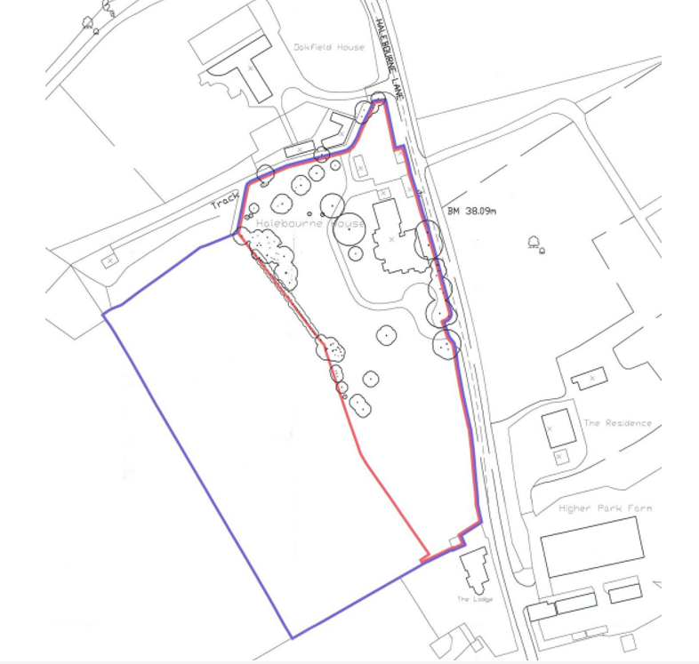

EXHIBIT 1 - DAVID GUYAN – STATEMENT OF TRUTH

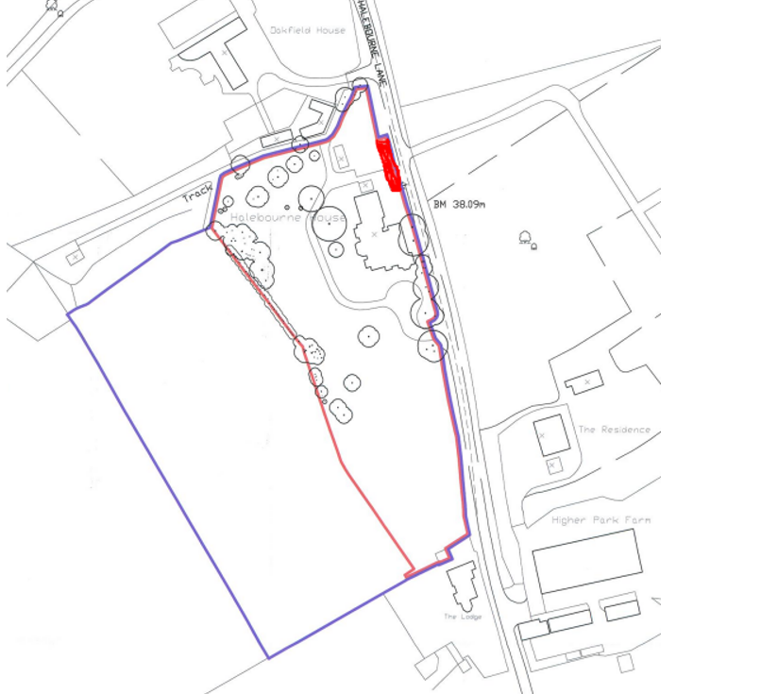
EXHIBIT 2 – DAVID GUYAN – STATEMENT OF TRUTH

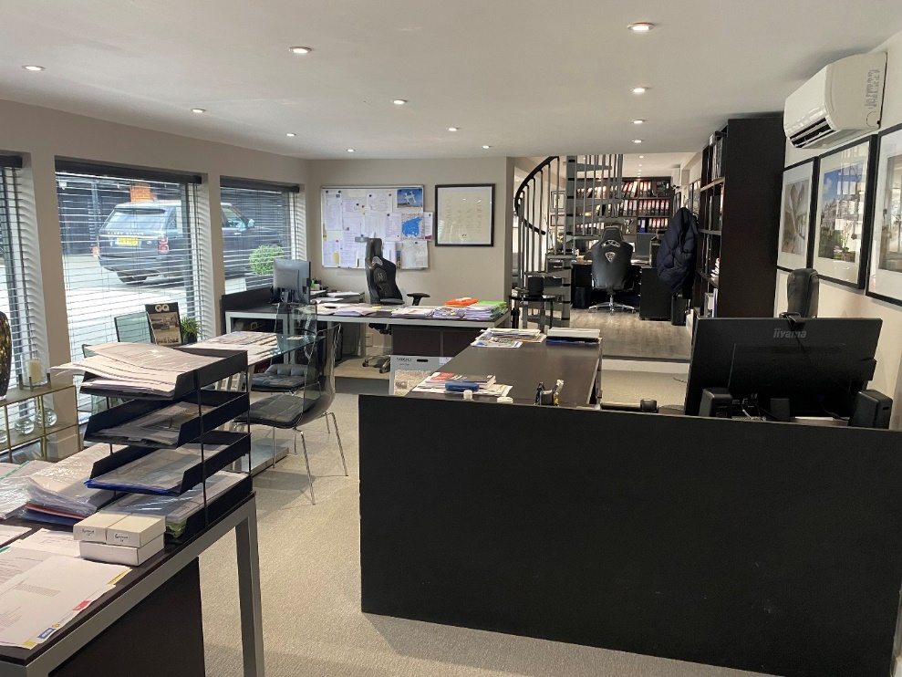
Office at Halebourne House, Halebourne Lane - Interior Photo 1 – Ground Floor
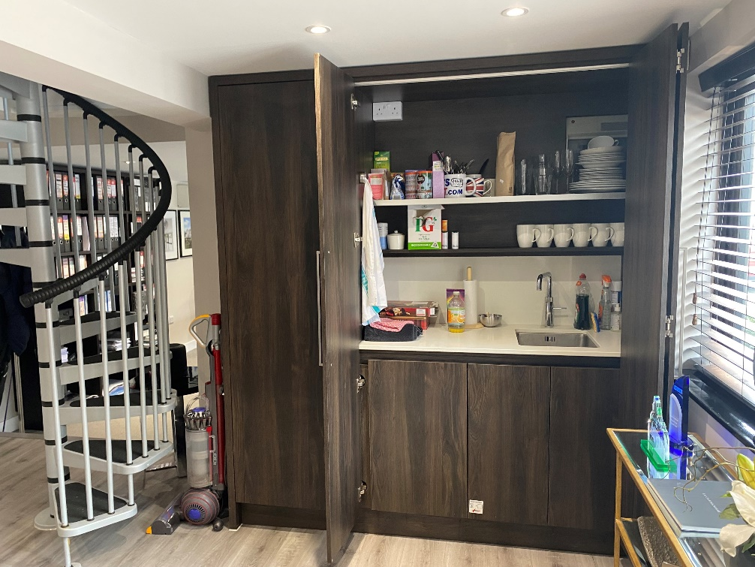
Office at Halebourne House, Halebourne Lane - Interior Photo 2 – Ground Floor

EXHIBIT 3 – DAVID GUYAN – STATEMENT OF TRUTH (INTERIOR PHOTOGRAPHS)

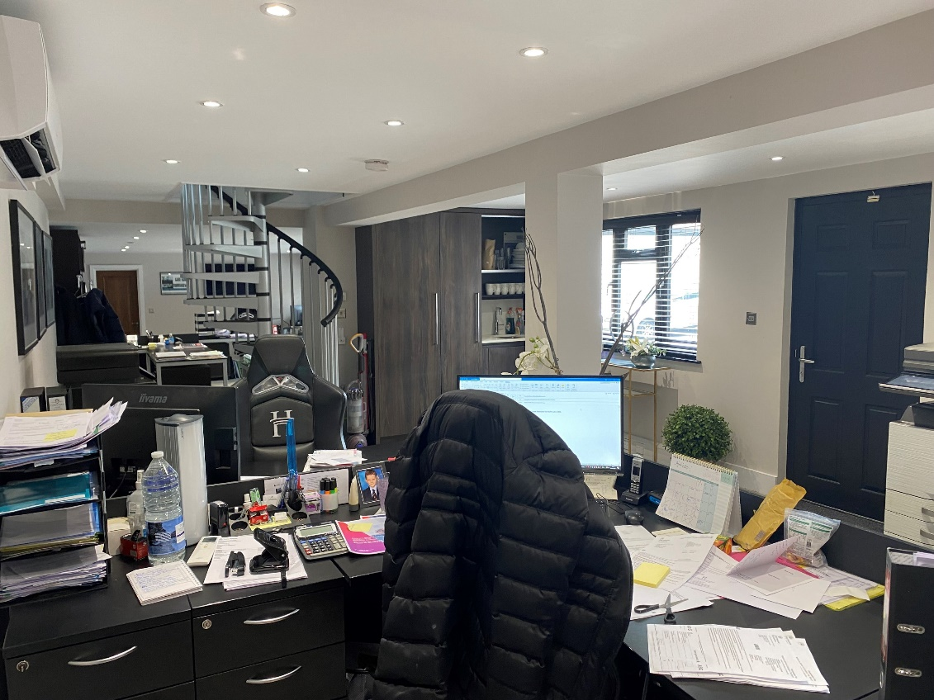
Office at Halebourne House, Halebourne Lane - Interior Photo 3 – Ground Floor
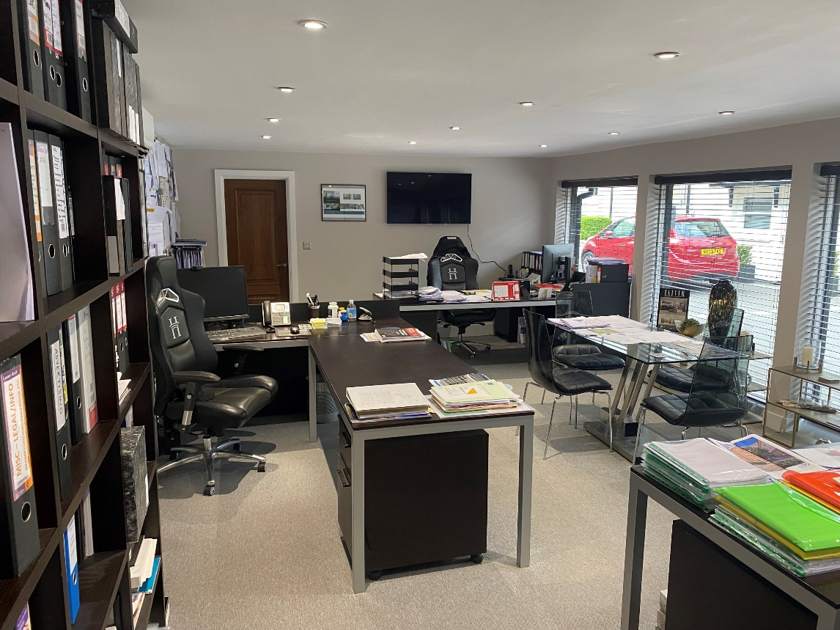
Office at Halebourne House, Halebourne Lane - Interior Photo 4 – Ground Floor

EXHIBIT 3 – DAVID GUYAN – STATEMENT OF TRUTH (INTERIOR PHOTOGRAPHS)
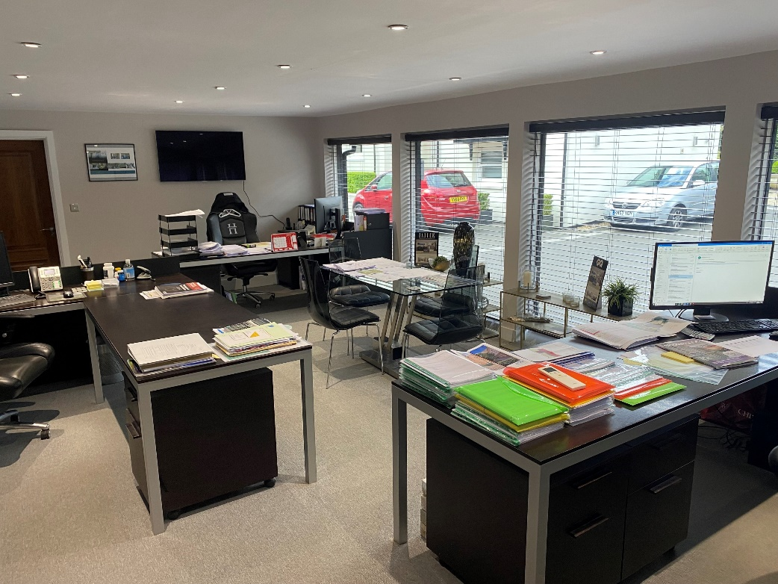

Office at Halebourne House, Halebourne Lane - Interior Photo 5 – Ground Floor
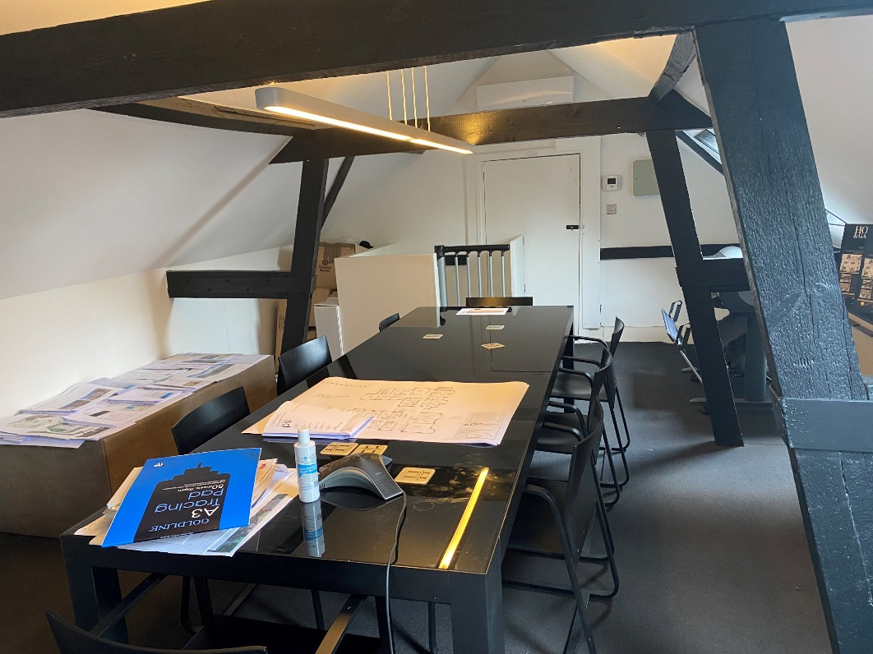
Office at Halebourne House, Halebourne Lane - Interior Photo 6 – First Floor

EXHIBIT 3 – DAVID GUYAN – STATEMENT OF TRUTH (INTERIOR PHOTOGRAPHS)

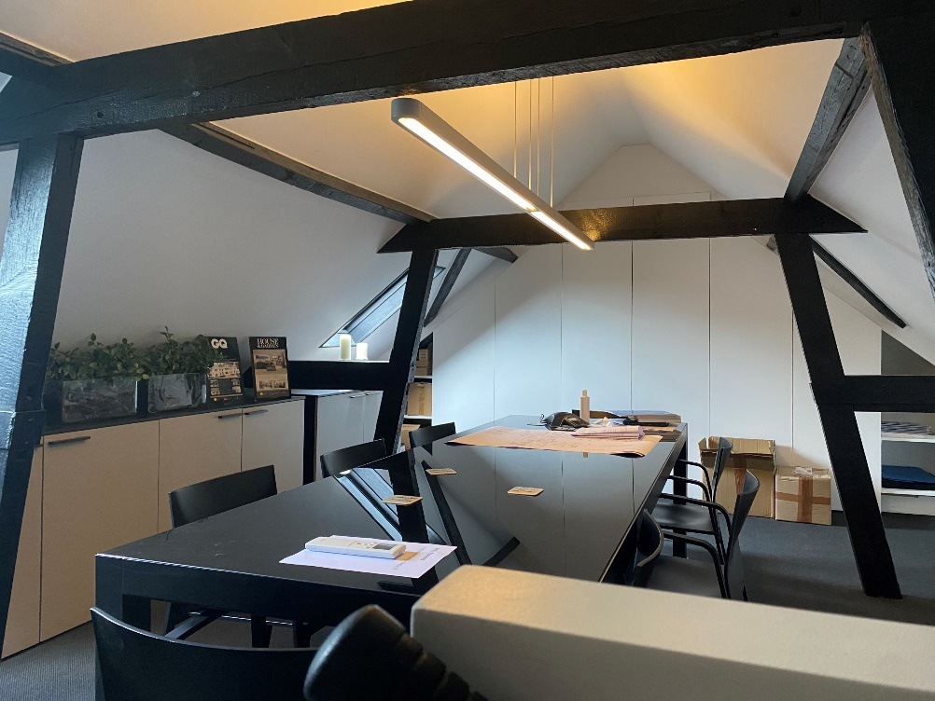
Office at Halebourne House, Halebourne Lane - Interior Photo 7 – First Floor

EXHIBIT 3 – DAVID GUYAN – STATEMENT OF TRUTH (INTERIOR PHOTOGRAPHS)

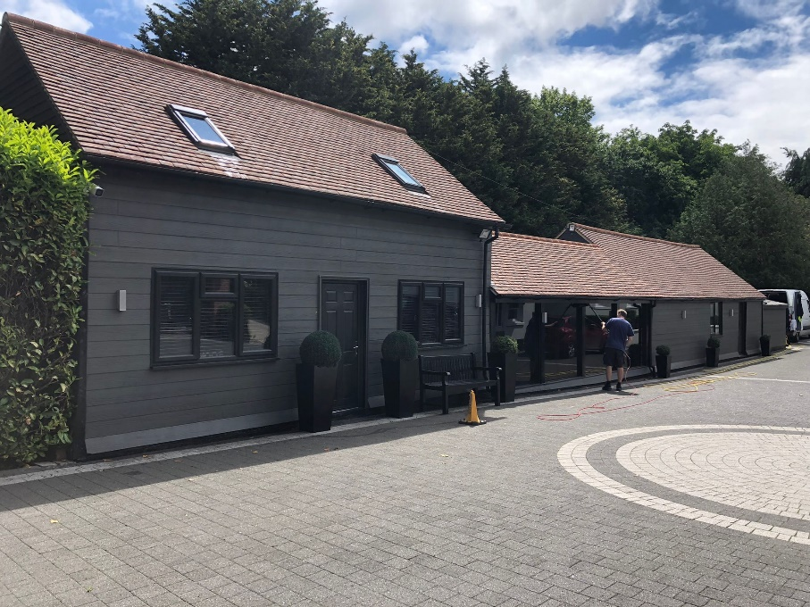

Office at Halebourne House, Halebourne Lane – Exterior Photo 1 – Showing Front of the Office Building.
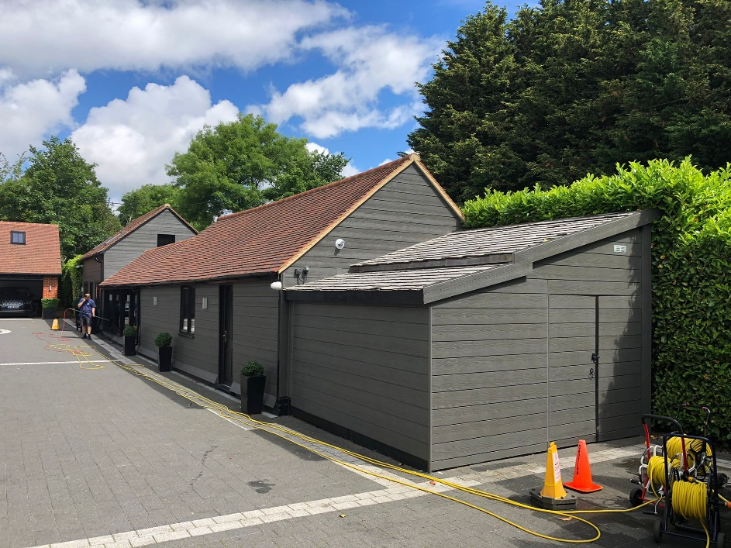

Office at Halebourne House, Halebourne Lane – Exterior Photo 2 – Showing Front of the Office Building.

EXHIBIT 4 – DAVID GUYAN – STATEMENT OF TRUTH (EXTERIOR PHOTOGRAPHS)

