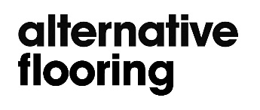
Customer Services Confirmation
Company Ref:
From: Alternative Flooring
Subject: Hand-made crafted carpet - Customer Information
___________________________________________________________________________
Important information on all Barefoot and Plush ranges
Our hand-made carpets are luxury handcrafted textiles and are sold around the world.
Due to the nature of these products, we would like to make you aware of certain information before we supply you with the carpet.
- Hand-made carpets do not display a machine made finish. Like most hand-crafted textiles, these craft products are not uniform and can show irregularities and imperfections on the surface.
- Joining or seaming a hand crafted carpet can prove difficult, as the pile height may not be exact.
Product specific:
- Barefoot carpets are made predominantly from undyed yarn and whilst our quality control procedures check for colour tolerances, slight variations in the colour from the sample provided can be expected. If colour matching is critical, please order a stock sample.
- Barefoot Bikram and Plush carpets will show signs of shading. Please refer to Alternative Flooring’s website or brochure to see the product shown in a large piece and the shading that will occur.
Please sign below (on behalf of your company) to say you are aware of the points above.
The signing of this confirmation will not affect your statutory rights.

Signed: _________________________ Print name:_____________________________

Company:_______________________ Position:________________________________

Date:__________________________ Email:__________________________________

