

Fine Velvet

Pile Content : | 100% Polypropylene , Velvet
Construction : | Tufted , 2 ply - 1/10th gauge
Widths Available: | 4m & 5m
Number of Colours: | 13
Backing: | Action
Colour Names: | Suede, Cord, Tallow, Harbour Grey, Egg Shell, Purbeck, Cromarty, Pheasant, Mineral, London Stone, Royal Navy, Pillar Box, Olive
Tog Rating: | 1.50
Pile Height: | 10 mm
Total Height: | 12 mm
Pile Weight | 1760 g/m2
Total Weight | 2660 g/m2
Suitability: | Heavy Domestic

To British Standard BS5325:1996 – Code of Practice for the Installation of Textile Floorcoverings.

MAINTENANCE

For day to day cleaning, use of a vacuum cleaner is recommended. Professional Cleaning by Dry Cleaning Extraction or Hot Water Extraction is recommended to prolong the life of the carpet.

Slight variations in colour may be experienced from dye lot to dye lot. Carpets can develop light and dark patches in use caused by shading and pile reversal. This in no way detracts from the wearing
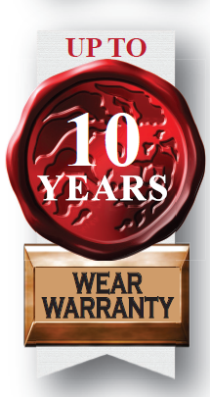
Qualities of the carpet. This condition can occur in all pile fabrics. It cannot be created during manufacture. Therefore should it occur, claims of faulty manufacture would not be accepted.




