
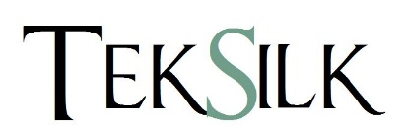

Installation
If you require colour matching then please let us know when placing your order. For all contract installations we recommend an all over stick down method.

Maintenance
Correct and regular maintenance will increase your carpet life for longer. We do not recommend light shades in heavy traffic areas. Regular vacuuming once a week will maintain the look of your carpet however we recommend twice a week for heavy traffic areas. ‘Shading’ is the effect of unequal pressure on pile carpets and is a natural characteristic, not a manufacturing fault. We recommend an upright vacuum cleaner with a beater bar on all of our products.

Important
Due to the limitations of dye technology, colours may vary from those shown on your samples.
It is strongly recommended that a protection mat or keyhole mat is used under castor chairs.
No claims will be considered as a result of improper application, installation or maintenance.
Carpet cleaning should always be done by a professional, do not attempt to clean your carpet without consulting a professional as you may damage your carpet.
Solitaire
Type | Velour
Yarn Content | TekSilk 100% PA Nylon 6.6
Gauge | 1/10”
Tuft Density (Tufts / m²) | 193,060
Pile Weight (Gr./m²) | 1000
Total Weight (Gr./m²) | 1900
Pile Height | 8mm
Total Height | 9mm
Width | 4 Metre
Backing | Ceneva® Actionbac®
Number of colours | 9
Rating | Heavy Domestic 23  Medium Contract 32
Tog Rating | 1.3
Colours
Pyrite | Moonstone
Topaz | Amber
Mica | Basalt
Agate | Graphite
Spinel
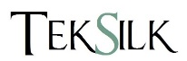

Product Specification

