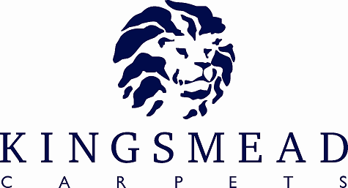

Artistry

Product Specification Sheet

Pile Content : | 50% Lambswool 50% Polyester
Gauge: | 5/32nd Gauge
Construction : | Loop
Widths Available: | 4 & 5 M Stripes 4M ONLY
Number of Colours: | 11 Plains, 5 Stripes
Backing: | Secondary
Colour Names: | ANTIQUE, CHIFFON, DENIM, IVORY, LILAC, PEARL, PEBBLE, TEAL, SAGE, SILVER, STR DUNMORE, STR KINGHTSBRIDGE, STR MAUVE BLUSH, STR PARK LANE, STR ROYAL MAYFAIR

Pile Weight | 1150gms
Total Weight | 2000gms
Pile Height | 6mm
Total Height | 8mm
Suitability: | Heavy Domestic

INSTALLATION

To British Standard BS5325:1996 – Code of Practice for the Installation of Textile Floorcoverings.

MAINTENANCE

For day to day cleaning, use of a vacuum cleaner is recommended. Professional Cleaning by Dry Cleaning Extraction or Hot Water Extraction is recommended to prolong the life of the carpet.

All cut pile textures can show colour variation where the lay direction of the pile varies in adjacent areas. This is not a manufacturing fault. Wool products being natural in origin may show occasional variations, such as black hairs. While every effort is made to grade the wool prior to tufting, we cannot guarantee that there will be no black hairs in the plain carpets.



