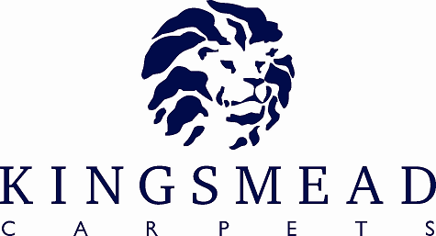

Stoddard Suffolk Berber

Product Specification Sheet

Pile Content : | 100% Wool
Construction : | 3 Ply Loop
Widths Available: | 4m & 5m
Number of Designs: | 2 Designs 7 Colours of Each
Backing: | Secondary
Colour Names: | Chalk, Corn, Olive, Steel, Sage, Dolphin, Lady Grey
Design Names: | Rib & Ripple

 | Ribb | Ripple
Pile Height: | 3 mm | 3 mm
Total Height: | 6 mm | 6 mm
Pile Weight | 1260 gm/m2 | 1100 gm/m2
Total Weight | 2560 g/m2 | 2400 g/m2
Tog Rating | 1.15 | 1.15
Suitability: | Heavy Domestic | Heavy Domestic

Slight variations in Colour may be experienced from dye lot to dye lot.

During the early stages of the carpet’s wear life, pilling and fuzzing may occur. This is a temporary phenomenon and the degree to which it may occur is entirely due to circumstances and the maintenance of the carpet. This is a normal feature and is not a defect in manufacturing.

INSTALLATION

All Carpets should be installed in accordance with BS5325

MAINTENANCE

For day to day cleaning, use of a vacuum cleaner is recommended. Professional Cleaning by Dry Clean Extraction is recommended to prolong the life of the carpet.
