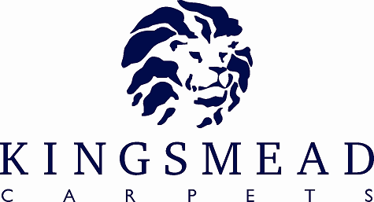

Natural Rib

Product Specification Sheet

Pile Content : | 100% Wool Loop
Gauge: | ¼ Gauge
 | 3ply
 | GB Made
Construction : | Loop
Widths Available: | 4m & 5m
Number of Colours: | 12 colours
Backing: | Fusion Soft Backing
Colour Names: | Smokey, Cardamon, Kasmir, Natural, Tusk, Hessian, Swedish Grey,  Nickel, Dill, Clay, Cord, Jute
Tog Rating | 1.61

Pile Weight | 1275
Total Weight | 2275
Suitability: | Heavy Domestic

INSTALLATION

To British Standard BS5325:1996 – Code of Practice for the Installation of Textile Floorcoverings.

MAINTENANCE

For day to day cleaning, use of a vacuum cleaner is recommended. Professional Cleaning by Dry Cleaning Extraction or Hot Water Extraction is recommended to prolong the life of the carpet.

All cut pile textures can show colour variation where the lay direction of the pile varies in adjacent areas. This is not a manufacturing fault. Wool products being natural in origin may show occasional variations, such as black hairs. While every effort is made to grade the wool prior to tufting, we cannot guarantee that there will be no black hairs in the plain carpets.



