SALE
  Hatfield
  100% Wool
  Heavy Domestic Use
  Available 4m & 5m
  Was £44.50m²
  NOW  ONLY | £37.82m²  If Purchased with  New Underlay
  Lyme Park
  70% Wool 30% Polyester
  Heavy Domestic Use
  Available 4m & 5m
  Was £44.50m²
  NOW  ONLY | £37.82m²  If Purchased with  New Underlay
  Wentworth
  100% New Zealand Wool
  Heavy Domestic Use
  Available 4m & 5m
  Was £58.00m²
  NOW  ONLY | £49.30m²  If Purchased with  New Underlay
  Chatsworth
  100% New Zealand Wool
  Heavy Domestic Use
  Available 4m & 5m
  Was £56.25m²
  NOW  ONLY | £47.81m²  If Purchased with  New Underlay
  Alboran
  100% Wool
  Heavy Domestic Use
  Available 4m & 5m
  Was £35.75m²
  NOW  ONLY | £26.81m²  If Purchased with  New Underlay
  Elements
  100% Wool
  Heavy Domestic Use
  Available 1,2,3,4&5m
  Was £54.00m²
  NOW  ONLY | £40.50m²  If Purchased with  New Underlay
 | 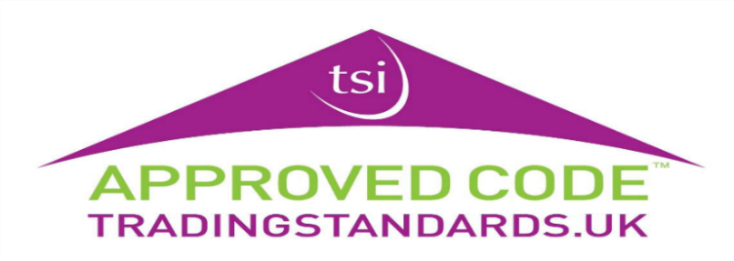
  Boston
  100% Wool
  Heavy Domestic use
  Available 4m & 5m
  Was £50.75m²
  NOW  ONLY | £38.06m²  If Purchased with  New Underlay

