SALE
  Hatfield
  100% Wool
  Heavy Domestic Use
  Available 4m & 5m
  Was £47.75m²
  NOW  ONLY | £40.59m²  If Purchased with  New Underlay
  Lyme Park
  70% Wool 30% Polyester
  Heavy Domestic Use
  Available 4m & 5m
  Was £46.25m²
  NOW  ONLY | £39.32m²  If Purchased with  New Underlay
  Wentworth
  100% New Zealand Wool
  Heavy Domestic Use
  Available 4m & 5m
  Was £63.00m²
  NOW  ONLY | £53.55m²  If Purchased with  New Underlay
  Chatsworth
  100% New Zealand Wool
  Heavy Domestic Use
  Available 4m & 5m
  Was £64.00m²
  NOW  ONLY | £54.40m²  If Purchased with  New Underlay
  Alboran
  100% Wool
  Heavy Domestic Use
  Available 4m & 5m
  Was £35.75m²
  NOW  ONLY | £26.81m²  If Purchased with  New Underlay
  Elements
  100% Wool
  Heavy Domestic Use
  Available 1,2,3,4&5m
  Was £59.75m²
  NOW  ONLY | £44.81m²  If Purchased with  New Underlay
 | 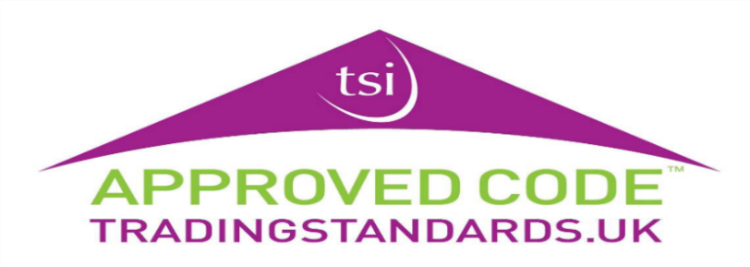
  Boston
  100% Wool
  Heavy Domestic use
  Available 4m & 5m
  Was £50.75m²
  NOW  ONLY | £38.06m²  If Purchased with  New Underlay

