
  Hatfield
  100% Wool
  Heavy Domestic Use
  Available 4m & 5m
  Was £45.50m²
  NOW  ONLY | £40.95m²  If Purchased with  New Underlay
  Lyme Park
  70% Wool 30% Polyester
  Heavy Domestic Use
  Available 4m & 5m
  Was £44.50m²
  NOW  ONLY | £40.05m²  If Purchased with  New Underlay
  Wentworth
  100% New Zealand Wool
  Heavy Domestic Use
  Available 4m & 5m
  Was £60.00m²
  NOW  ONLY | £54.00m²  If Purchased with  New Underlay
  Chatsworth
  100% New Zealand Wool
  Heavy Domestic Use
  Available 4m & 5m
  Was £58.00m²
  NOW  ONLY | £52.20m²  If Purchased with  New Underlay
  Alboran
  100% Wool
  Heavy Domestic Use
  Available 4m & 5m
  Was £33.75m²
  NOW  ONLY | £28.60m²  If Purchased with  New Underlay
  Elements
  100% Wool
  Heavy Domestic Use
  Available 1,2,3,4&5m
  Was £54.00m²
  NOW  ONLY | £43.20m²  If Purchased with  New Underlay
 | 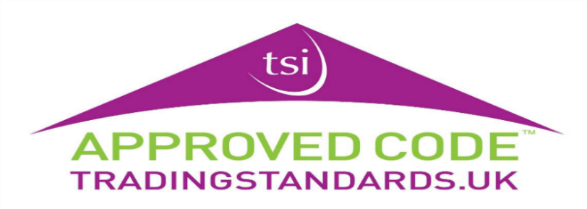
  Boston
  100% Wool
  Heavy Domestic use
  Available 4m & 5m
  Was £55.25m²
  NOW  ONLY | £44.20m²  If Purchased with  New Underlay

