
  Lior Smartstrand
  100% Triexta
  Heavy Domestic Use
  Available 4m & 5m
  Was £63.00 m2
  NOW  ONLY |  |  |  |  | £53.55m2  If Purchased with New Underlay
  Shiruku T&C
  100% Nylon 6.6
  Extra Heavy Domestic Use
  Available 4m & 5m
  Was £86.25 m2
  NOW  ONLY |  |  |  |  | £69.00m2  If Purchased with New Underlay
  Tyrol
  100% Nylon 6.6
  Extra Heavy Domestic Use
  Available 4m & 5m
  Was £100.25 m2
  NOW  ONLY |  |  |  |  |  | £90.23m2  If Purchased with New Underlay
  Silk Luxury Velour
  100% Synthetic
  Extra Heavy Domestic Use
  Available 4m only
  Was £134.25 m2
  NOW  ONLY |  |  |  |  | £107.40m2  If Purchased with New Underlay

 |  | 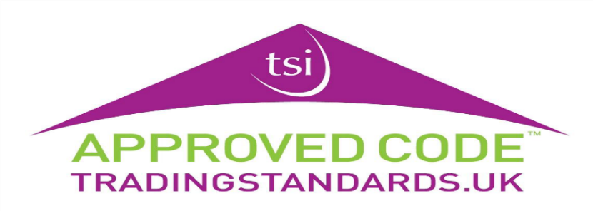
  Suede T&C
  100% Solution dyed nylon
  Extra Heavy Domestic Use
  Available 4m & 5m
  Was £87.25m2
  NOW  ONLY |  |  |  |  | £69.80m2  If Purchased with New Underlay

