Website Update
Many of you have commented that you receive complaints that our website does not work. I think the issue was the products page was only set up previously to list the products we sell and they didn’t link to anything so when people understandably clicked on the item it had no link to take them to.
I will not put our ranges on the website as this will enable our competitors to easily identify our de branded ranges. As you know Josh has recently added a contacts page to the website and for clearance carpets, carpets & runners there is a link to the contact us page from these pages.
The Bespoke rugs, LVT and Moods opens a link to the suppliers website but for the bespoke rugs it takes them to alternative floorings site via our branch selection page so they cannot look up other retailers from their site.
See screen shots below and try it for yourself. If when you log on to the Mr Carpet website you do not see the new pages you are probably viewing in cache on your machine and if you look to the right of the web address in the top line there is a curved arrow, if you click on this it will refresh the page and show you the new pages.
DG

See Below for screenshots
The pages below show you the page that you will see when you click on the relevant product link. I have replaced wood with clearance.

Home Page
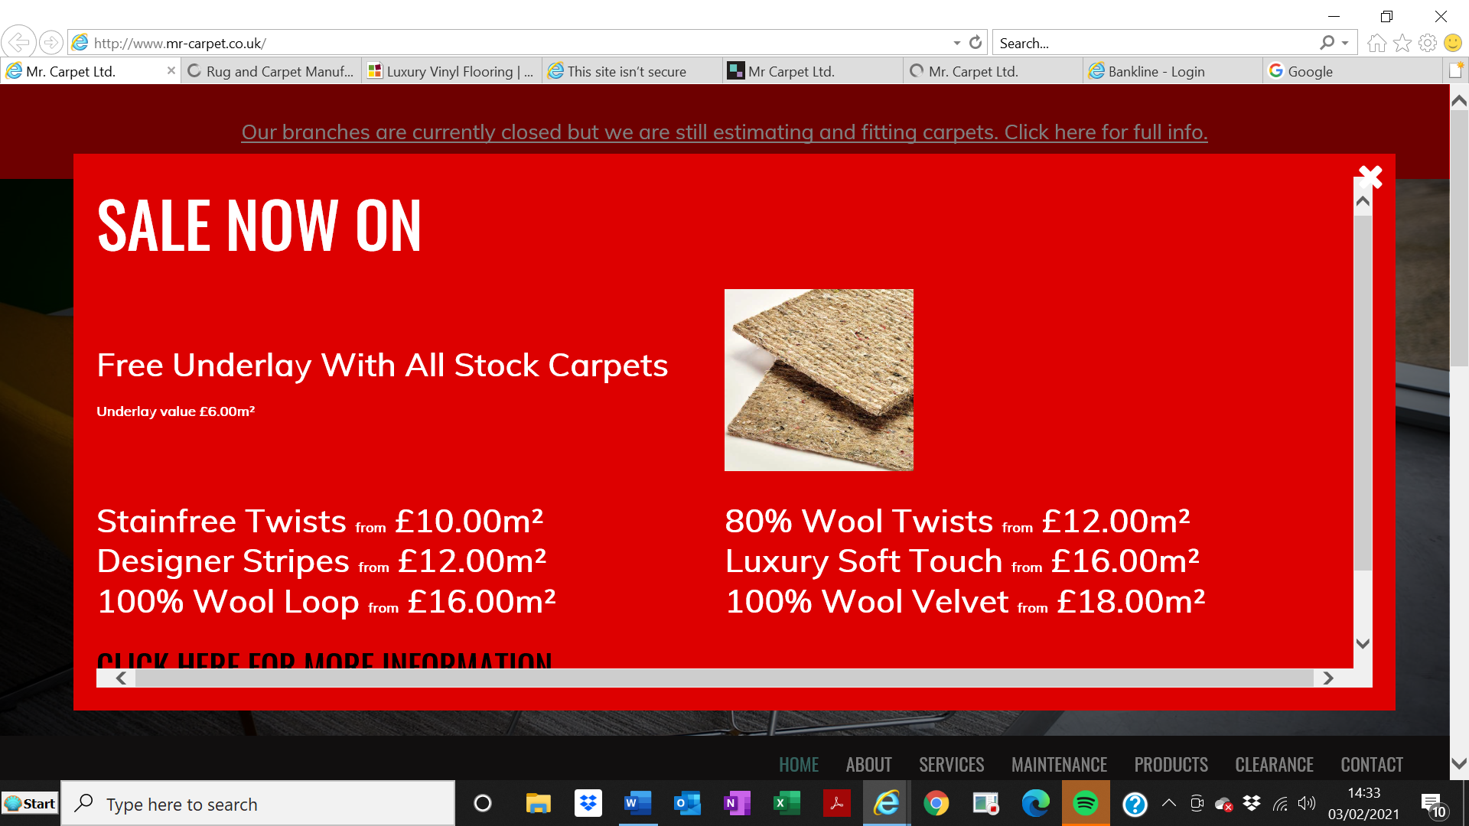

Close Sale pop up and Select Products from the menu (Bar menu on phone screens)
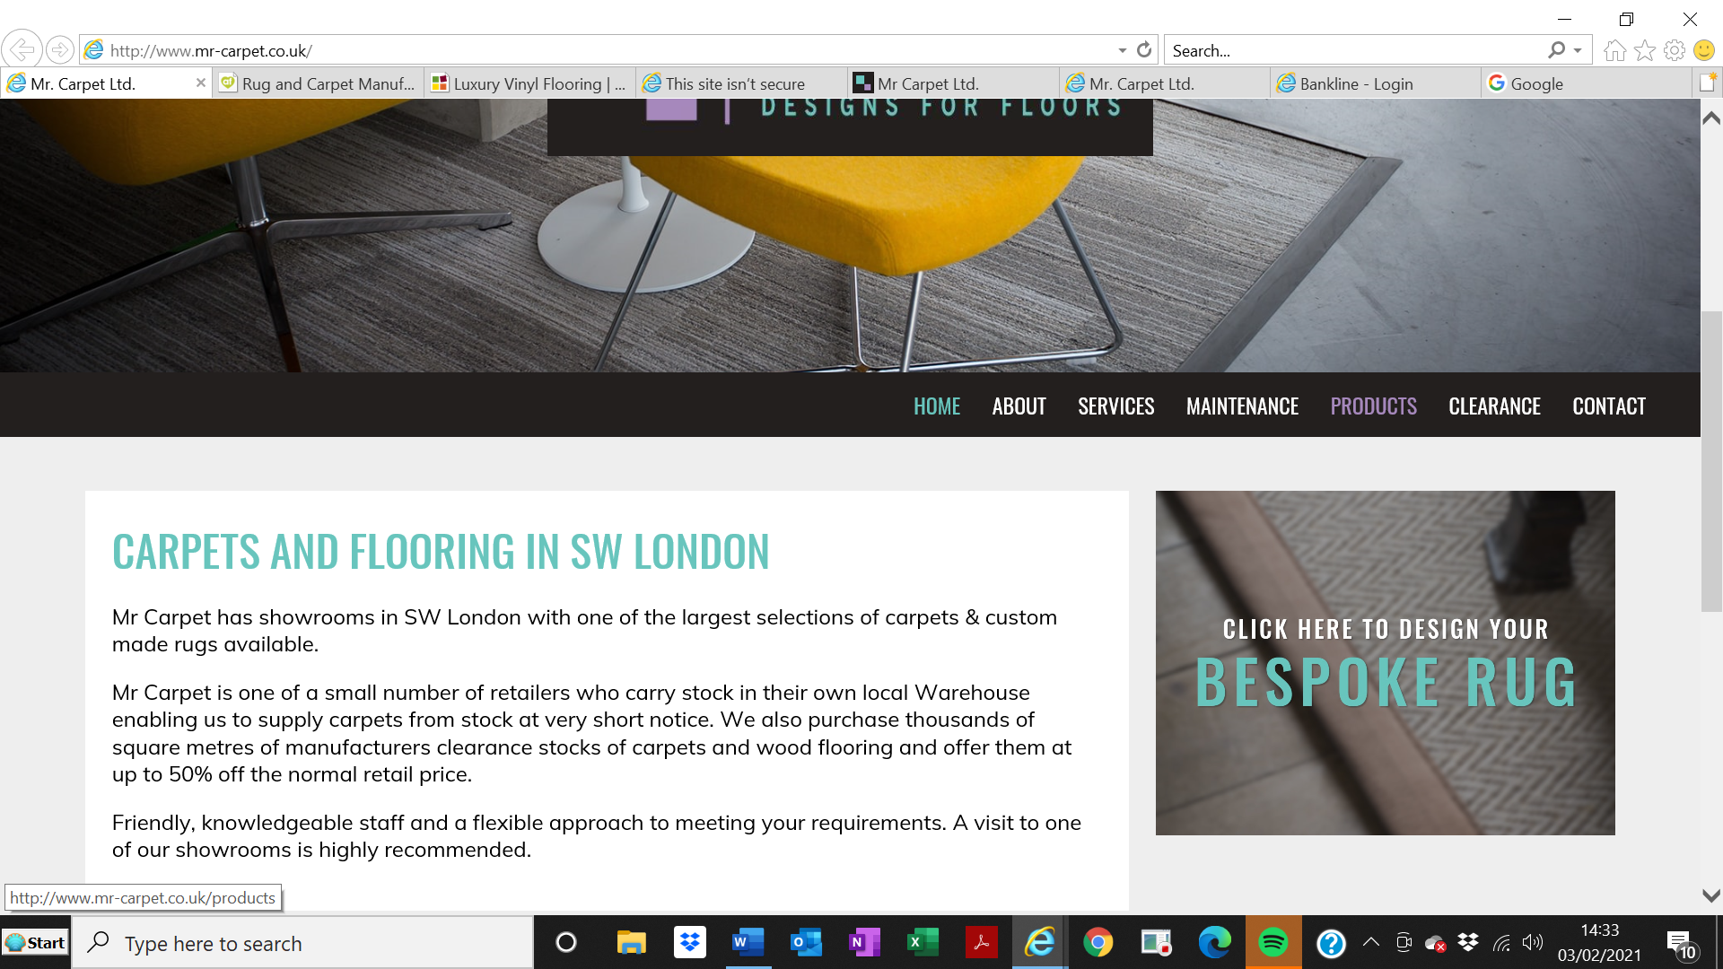

Select the product link
